Leonhard Kurz at Labelexpo:
New finishing effects and narrow web cold foils

Fürth/Germany, 19 July 2019: Leonhard Kurz will present new stamping foil series for rotary label printing at this year’s Labelexpo Europe, and demonstrate the effective interplay of digital web-fed printing and integrated metallization.

The KPW XU cold foil grade, a versatile go-to for narrow-web printing, will be presented for the first time at Labelexpo. According to the manufacturer, this cold foil is exceptionally suited for overprinting and delivers optimal decoration results both for large-area and fine designs.

A further development is the availability now of a Lumafin semi-transparent stamping foil specifically for web-fed printing. It allows underprinted designs to shine through, covers them with a shimmering gloss, and creates an extraordinary depth effect. A variety of labels decorated with Lumafin and demonstrating the interplay of color printing and Lumafin decoration will be on display at Labelexpo.

A focal point of the Kurz booth will be digital finishing using the DM-Jetliner. At the trade fair booth, there will be a live demonstration of an HP Indigo 6900 digital printing machine with an integrated DM-Jetliner finishing module, which will be used to metallize web-fed labels at printing speeds and overprint them in a single pass. Trade fair visitors can observe the seamless integration of the DM- Jetliner into the printing process and the creation of luminous metallic colors, decorative individualized elements, and holographic effects. Visit the Kurz booth 3D40 to discover the wide range of design effects that can be achieved.

□□□

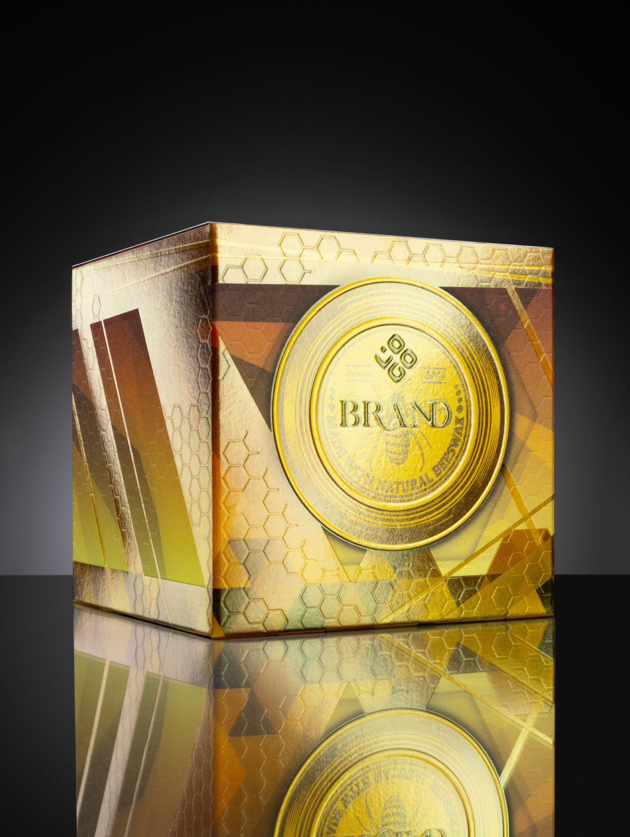
The Lumafin semi-transparent stamping foil allows underprinted designs to shine through.
(Photo: Kurz)

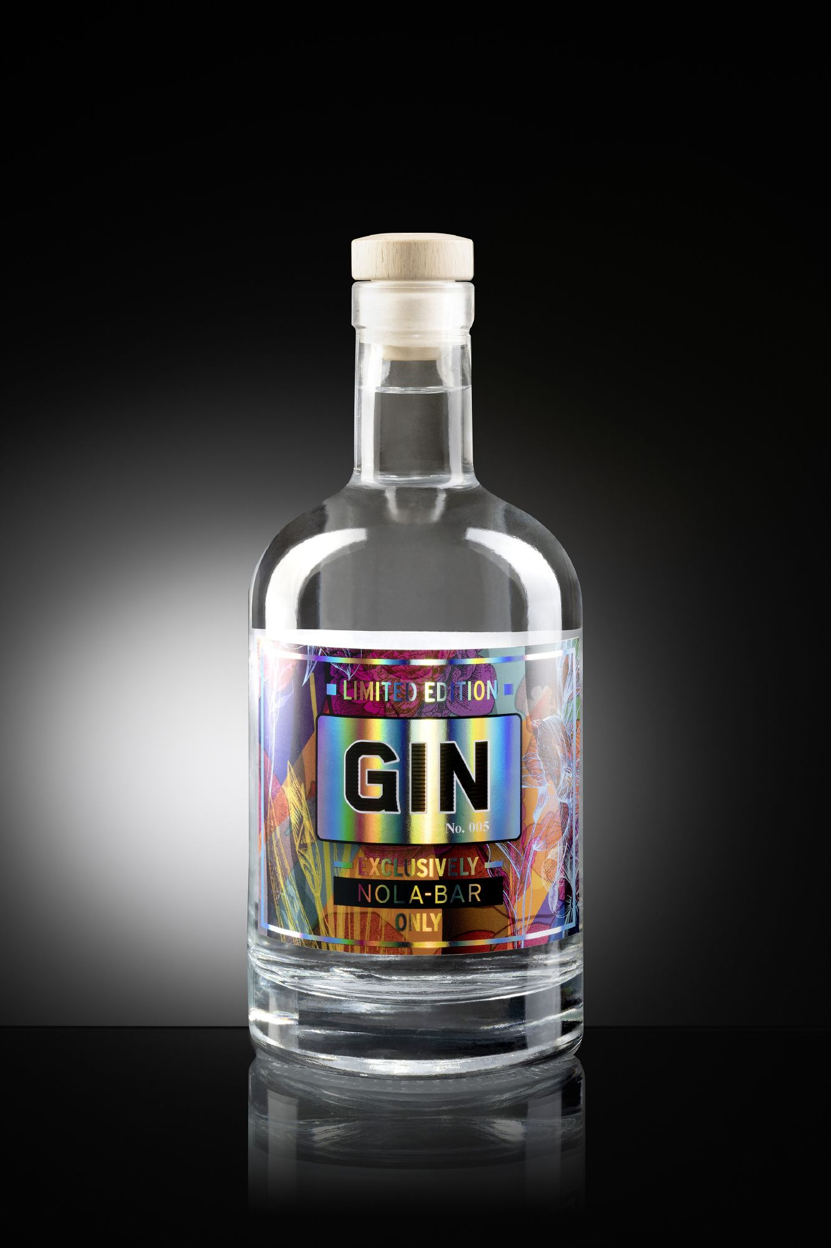
Label finished using the Kurz DM-Jetliner
(Photo: Kurz)

□□□

About KURZ: The KURZ Group is a global leader in thin film technology. KURZ develops and manufactures decorative and functional layers applied to carrier foil for a wide range of industries, from the packaging and printing industry through to the automotive, electronics, card and textile sectors. KURZ offers a comprehensive portfolio of products for surface finishing, decoration, labeling, and counterfeit protection, rounded off by an extensive range of stamping machines and stamping tools. The company is also continuously investing in new technologies and developing innovative solutions for integrating functionality into surfaces. The KURZ Group has more than 5,000 employees at over 30 sites worldwide and produces under standardized quality and environmental standards in Europe, Asia, and the USA. A global network of subsidiaries, representatives, and sales offices ensures short paths and individual, on-site consulting.

www.kurz.de

Press Contact:

Lucie Mengel
LEONHARD KURZ Stiftung & Co. KG
Schwabacher Straße 482, 90763 Fürth/Germany
Phone: +49 911 71 41-96 38, Fax: +49 911 71 41-96 40
E-Mail: lucie.mengel@kurz.de
www.kurz.de

